Awards and Honors Application Template

<Insert Award Name>  Illinois Academy of Nutrition and Dietetics  20xx Application | 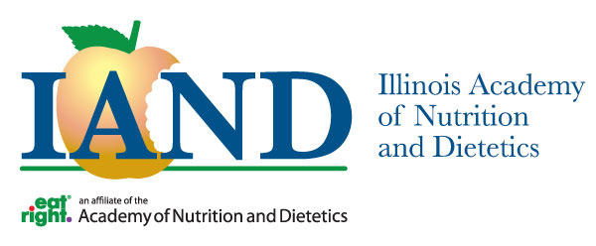

MEMBER INFORMATION

Please provide the following information.
Academy Membership Number
First Name
Middle Initial
Last Name

Address
Street
City
State
Zip
Email Address

District (if applicable)
District

STUDENT'S CURRENT EDUCATIONAL PROGRAM ( if applicable)

Institution Name
City/State

Dietetics Education Program Type (circle one)
CP | CI | DPD | DT

ACTIVITIES AND HONORS
Briefly list achievements including: honors (academic and other), student dietetic association activities, community service activities, etc.

Activities, Honors, or Organizations: | Dates

(Insert additional criteria)

ADDITIONAL INFORMATION
- All applications must be returned by XX/XX/XXXX
- Students must supply their membership number; membership identification numbers will not be provided to third parties (i.e., educators). Nominations through affiliates.
- Complete this form and return to Margery R. Ruch, RDN, LDN
iandawards@gmail.com
309-824-6595

MEMBER CERTIFICATION
I have reviewed the criteria for this award and attest that I have not received this award from this or any other affiliate previously as well as meet all other criteria for the award I am applying for
Signature: Date:

